Zadanie 05

Stiahi si z materialov "**(DÚ) adventure ZADANIE**".  
Otvor to a uvidis jeden modry box. S popisom postavy z Adventure Time.

**Ciel ulohy je, aby sa vedla seba zobrazovalo 5 boxov.  
S popisom 5tich postav z Adventure Time.**

Tieto popisy (a pocet komentarov, ktore na konci spocitas) najdes v tomto JSONe:

[

{

"who": "Finn the Human",

"wat": "Finn is a silly kid who wants to become a great hero one day. He might not look too tough, but if there's evil around, he'll slay it. That's his deal.",

"comments": 4

},

{

"who": "Jake the Dog",

"wat": "Finn's best friend is a wise, old dog with a big heart. Jake has the magical ability to stretch and grow. When evil's not running amok, he plays viola with Lady Rainicorn.",

"comments": 23

},

{

"who": "Ice King",

"wat": "Armed with a magic crown and an icy heart, the Ice King has only one goal: to secure a wife by any means necessary.",

"comments": 10

},

{

"who": "Princess Bubblegum",

"wat": "As a millionaire nerd enthusiast, Princess Bubblegum immerses herself in every branch of geekdom from rocket science to turtle farming.",

"comments": 44

},

{

"who": "Marcy the Vampire",

"wat": "Marceline is a wild rocker girl. Centuries of wandering the Land of Ooo have made her a fearless daredevil.",

"comments": 10

}

]

Tento JSON vloz do tvojho kodu*. Vznikne ti pole objektov.  
Prebehni toto pole objektov cez forEach napriklad a dosiahni, aby tvoja stranka na konci vyzerala takto:

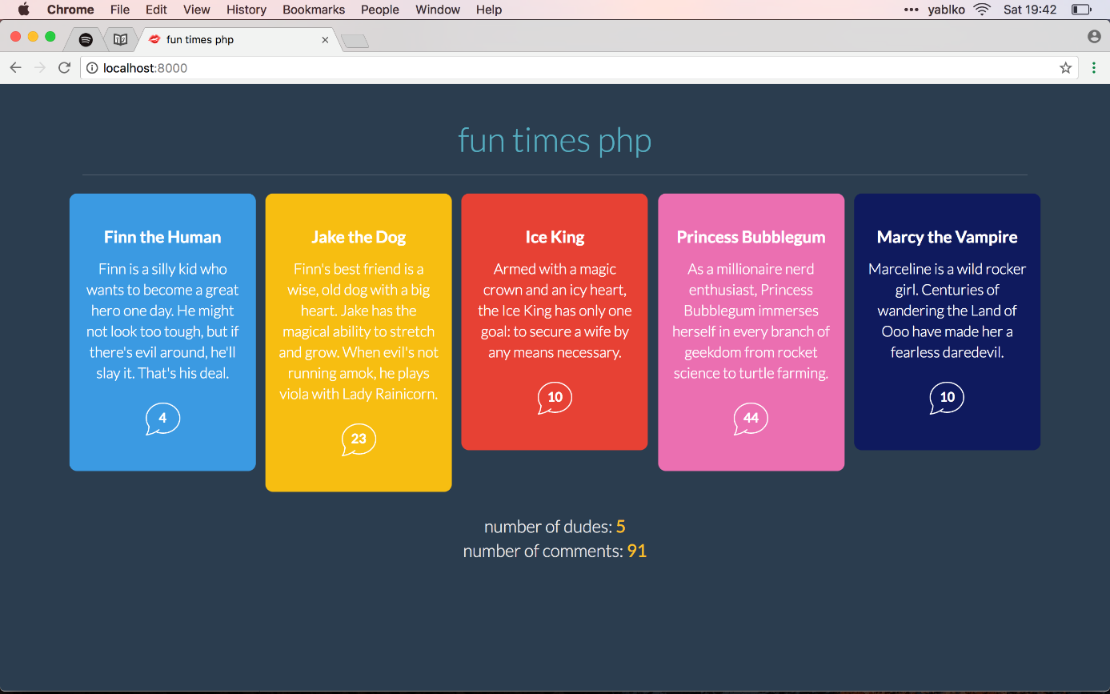

Do HTML kodu som pridal jeden article element na ukazku. Aby si videl ake HTML elementy mas vyrobit z toho JSON.

**Cize**:

* stiahni kod a otvor stranku
* skombinuj ho s JSONom tu hore
* tak aby stranka vyzerala ako na obrazku